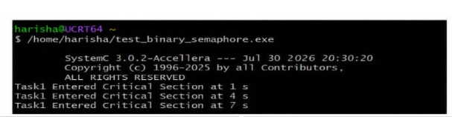#include <systemc.h>

SC_MODULE(binary_semaphore)
{
int sem;
sc_event ev;

void task1()
{
while (true)
{
wait(1, SC_SEC);

if (sem == 1)
{
sem = 0;

cout << "Task1 Entered Critical Section at "
<< sc_time_stamp() << endl;

wait(2, SC_SEC);

sem = 1;
ev.notify();
}
else
{
wait(ev);
}
}
}

void task2()
{
while (true)
{
wait(2, SC_SEC);

if (sem == 1)
{
sem = 0;

cout << "Task2 Entered Critical Section at "
<< sc_time_stamp() << endl;

wait(1, SC_SEC);

sem = 1;
ev.notify();
}
else
{
wait(ev);
}
}
}

SC_CTOR(binary_semaphore)
{
sem = 1;

SC_THREAD(task1);
SC_THREAD(task2);
}
};

int sc_main(int argc, char* argv[])
{
binary_semaphore obj("Binary_Semaphore");

sc_start(10, SC_SEC);

return 0;
}

